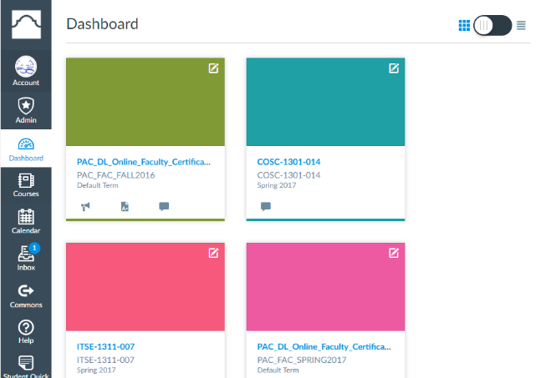
Canvas Overview

Accessing your courses:
- Log into Aces
- Click Canvas on the Home tab or Faculty tab (“Canvas Live” link on right)
- Dashboard (see image to the right) appears with your current courses click one to enter course
Assignments menu item:
- To create assignments
- To allocate percentages to grade groups (see image below)
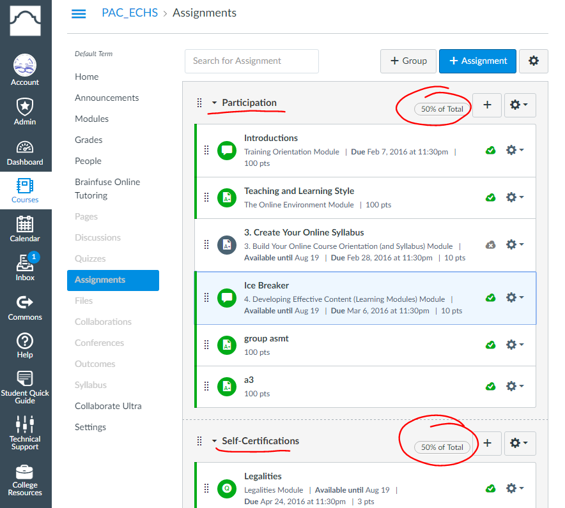

Sample Gradebook
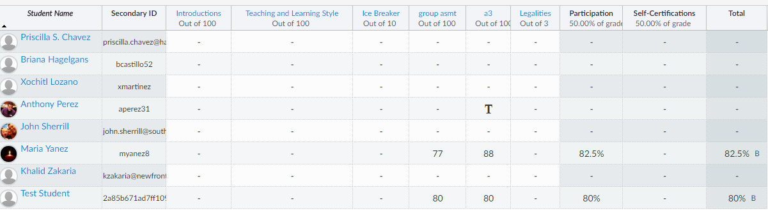
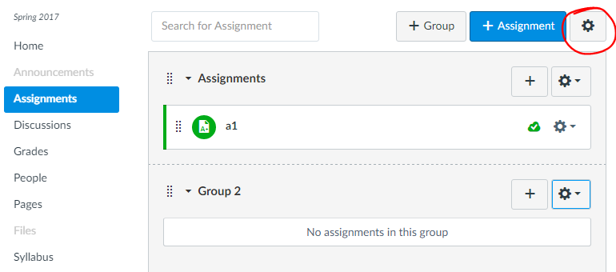
Gradebook Creation

Create Assignment Groups
- Click “Assignments” menu item
- Click “+ Group” on the top right, type the name and save

Create Assignments
- Click the “+” in the appropriate group
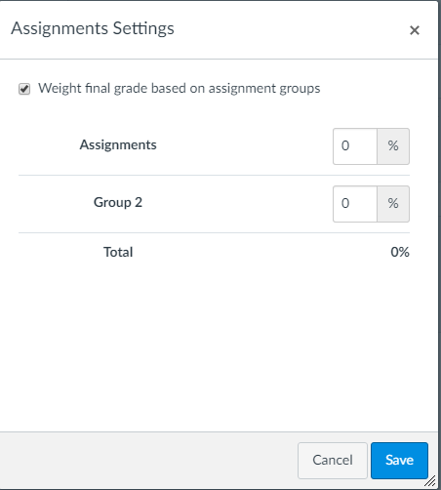
- Enter a title and the maximum amount of points for the assignment
- Click Save and Publish
- You can drag assignments from one group to another

Assign Percentages to Groups
- Click the gear button on the top right (see image 1)
- Choose “Weight final grade based on assignment groups” (see image 2)
- You can now allocate percentages to each of the groups
- Click “Save” when done

To allow students to see the gradebook, the course must be published. To publish the course, click the “Home” menu item and the “Publish” button to the right.

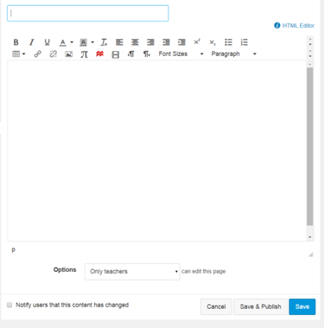
Creating a Home Page
You may want to create a home page to provide contact information, book information or the syllabus. To do this, follow these steps:

- Create page (Menu item “Pages” and click “+ Page” on top right)
- In the small box on the top left type “Home Page” (see image to the right)
- In the big input box, type the content for your home page including images if you choose.
- Click the “Save and Publish” button on the bottom
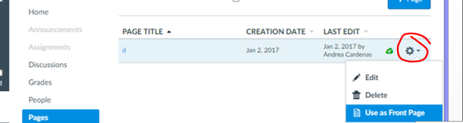
- Click “View all pages” button on top.
- Click gear button to the right (see image to the right)
- Choose “Front Page”
- Click the “Home” menu item
- Click “Choose Home Page” to the right and choose “Pages Front Page” and Save

