COVER PAGE
(will not be in final published document; used for mailing info)

Article Title: The Write Stuff: Cultivating and Assessing Grit in Framework-based Teaching

Celita Avila, Reference & Distance Learning Librarian & Fearless Learning Co-Director, San Antonio College, 1819 N. Main Ave., San Antonio, TX 78212
Karen Briere, Reference Librarian & Instructional Designer, San Antonio College, 1819 N. Main Ave., San Antonio, TX 78212
Ernest W. Tsacalis, Assistant Professor of English & Fearless Learning Co-Director, San Antonio College, 1819 N. Main Ave., San Antonio, TX 78212

Keywords for online searching (up to 10 of your choosing):
ACRL Framework, Searching as Strategic Exploration, Research as Inquiry, grit, growth mindset, student empowerment, information literacy, assessment, dispositions, Fearless Learning

The Write Stuff: Cultivating and Assessing Grit in Framework-based Teaching
Celita Avila, Karen Briere and Ernest Tsacalis

Introduction
Are we really helping students develop what it takes to make it? Librarians, writing center peer tutors, and course instructors at San Antonio College are on a journey towards building student confidence and persistence through a college-wide initiative called Fearless Learning: Empowering Students with Information Literacy. Not only are we looking to affect change in the mindset students have about the research process, but also to tilt current pedagogical practices in the library, the classroom, and at the tutoring table toward the dispositional elements outlined in the Framework for Information Literacy.

Grit and the Growth Mindset
Based on Professor Carol Dweck’s groundbreaking studies on motivation in education and the growth mindset and popularized by psychologist Angela Duckworth in her 2016 book Grit: The Power of Passion and Perseverance, “grit” has become a hot topic of debate in the academic realm. In 2013, a draft report from the U.S. Department of Education Office of Educational Technology on promoting grit listed nine contrasting definitions of this key term (p. 14). Our definition of grit is informed by the dispositional elements outlined in the ACRL Framework for Information Literacy for Higher Education (2015) which closely align with what Dweck calls the hallmark of the growth mindset: stretching yourself and sticking to it, even (or especially) when it’s not going well.
Our focus is on two frames: Research as Inquiry and Searching as Strategic Exploration, applying the language used in the definition of each frame along with selected dispositions. Both frames use the word “iterative” in their definitions, which points to research as a testing, refining, and growth process. Searching as Strategic Exploration includes “mental flexibility” and “alternate avenues” to signal that students practicing skills in this area will be required to do some stretching and exploring. Dispositions from both frames include more gritty, growth mindset language, specifically:
- consider research as open-ended exploration and engagement with information
- value persistence, adaptability, and flexibility and recognize that ambiguity can benefit the research process
- exhibit mental flexibility and creativity
- understand that first attempts at searching do not always produce adequate results
- persist in the face of search challenges, and know when they have enough information to complete the information task

The Framework sends a clear message that research is a non-linear, iterative process which requires thought, patience, and flexibility. Our goal as educators is not to make research easy, it is to help students persevere when this process becomes challenging. Librarian Michelle Reale (2016) suggests that we “Lay a foundation for students to create their own process, show them a way to begin, and to reassure them that it is okay not to know what you don’t know (p. 7).

Becoming Fearless
San Antonio College is one of the largest community colleges in Texas. As part of our college re-accreditation effort for The Southern Association of Colleges and Schools Commission on Colleges (SACS-COC), we have embarked on a college-wide information literacy initiative called Fearless Learning: Empowering Students with Information Literacy. The goal of the Fearless Learning Quality Enhancement Plan is to help first-time-in-college students persist in their reading, writing, and research efforts in core courses (Tsacalis, 2015). The Fearless Learning outcomes are that students will:
- develop a questioning approach to define and narrow a topic;
- create a flexible research strategy for an assignment;
- develop ideas and synthesize sources within a document or presentation;
- evaluate a variety of sources for the ethical and logical uses of evidence;
- use written or oral communication to convey meaning and build credibility;
- comprehend how to use appropriate style conventions and language to create the types of texts used to shape and share information with a discipline/profession.

Within the Fearless Learning initiative, writing center peer tutors, librarians, and core course instructors have engaged in a variety of cross-training activities. Participating in cross-training among these three groups of natural collaborators afforded us key insights into pedagogical approaches to help students grapple with the Framework’s grittier dispositional elements. Informed and influenced by the rhetorical skills and concepts found in the reading and writing world, librarians knew that a change in our approach to teaching and assessment would be required. Librarians went from rubrics-light grading of a few information literacy skills to multiple choice auto-feedback quizzes and have finally landed on our current assessment model which asks students to share what they’ve learned in writing. (Appendixes C-E) This initiative gave librarians the opportunity to remove themselves as the vessels of information and replace that with entrusting and empowering students to make their own meaning within the research process, just as course instructors and tutors ask them to do when they read and write. By providing students with a loose scaffold of activities where they can test, discuss, and continually revise their research approach, they can gain experience in navigating through what Meyer and Land (2006) call the “stuckness” of this non-linear, iterative process (p. 25).

Cultivating Grit
After multiple revisions, our new approach to library instruction for our Fearless Learning cohorts culminated in the Searching is Strategic Worksheet (SSW). (Appendix A) The SSW involves a multi-step process which encourages students to slow down and think critically by questioning and making their own meaning within the research process. Miller (2015) writes that by creating an explicitly rhetorical approach we can help students “fail forward” (p. 19) through the stuckness.
The Five Ws and Research Statement
We ask Fearless Learning course instructors to prepare their students before the library session by asking students to brainstorm the Five Ws—Who, What, When, Where, Why—as it applies to the students’ topics. Students and course instructors typically see research as a “search and find” problem when in reality it is a problem of conceptualization and thinking (Reale, 2016, p. 5). Low stakes writing, while utilizing divergent thinking and exploring potential research questions, gives students an opportunity to engage in the grittier aspects of the Framework. This engagement allows them to see that research is an open-ended exploration that can sometimes come with ambiguities. The SSW begins with students writing down their guiding research statement with the caveat that during the research process, this statement may need revision. Students then select words from the statement which carry the most meaning and best represent the ideas they wish to convey.
The Keyword Grid
According to Shechtman, DeBarger, Dornsife, Rosier & Yarnall (2013), "Students are also more likely to persevere when they can draw on specific strategies and tactics to deal with challenges and setbacks. They need actionable skills for taking responsibility and initiative, and for being productive under conditions of uncertainty..." (p. vii). By using a grid approach to keyword searching, students can visualize all the possible ways they could create a search string. This encourages flexibility and revision, as well as creativity, adaptability, and persistence.

Search Strings and Limits
Students use the SSW to construct a search string using their keywords, adapt and change their search string to find both relevant and manageable results, and choose limiting features to further refine their results to include the needed content types. Revising a search strategy is an exercise in what Duckworth (2016) calls ‘deliberate practice’. In a group work setting it is also an opportunity to seek help when challenged. Dweck (2016) says “A growth mindset isn’t just about effort. Students need to try new strategies and seek input from others when they’re stuck” (p. 1). The Framework Research as Inquiry reminds us that learners need to seek appropriate help and to value persistence, flexibility, and to understand that first attempts do not always produce adequate results.
Best Bets
At this point in the lesson, students engage in a think-pair-share activity to discuss and defend what they consider to be the “Best Bet” tool for their topic. Miller (2015) writes, “If students are going to fail forward, then they need to receive specific, relevant and timely feedback” (p. 28). Driving learning to a foreseeable goal helps to mitigate frustration and loss of control. This discussion allows the students to give voice to their challenges, recognize when they should persist, and also to know when they have found enough information to complete their task.
Peer Recommendations

In Gladwell’s book David and Goliath (2013), he references Robert and Elizabeth Bjork’s research on “desirable difficulties.” The SSW is blank when students begin. There are no right or wrong answers. Students have to slow down and think harder. The lesson plan is properly problematized so that students must use their self-created tool, the grid and their Five Ws, in order to move forward.
Rhetoricizing a learning opportunity imbues it with a purpose and an audience. By crafting their evaluations as recommendations for absent peers, students get to view themselves as valued and trusted shapers and sharers of information in a community of learners. The social accountability of this more purposeful communication slows students down so they can act on a sense of communal duty and good to ensure their evaluations are helpful and clear. This empowering design element replaces a passive reliance on librarian expertise with student agency. Their social and communal value and expectations lend the learning task more meaning, so that writing as a means of teaching a peer feels more engagingly vital than the passive completion of a worksheet that nobody will read or use. The communal affirmation of a student’s ability to teach inspires more grit.

Assessing Grit

The Library Instruction (LI) program started using student learning outcomes to design and assess its sessions in 2010. Its earliest assessment tools employed likert-scaled questions to measure student opinion and a few multiple choice and short answer questions to measure student mastery of the search skills the sessions taught. The assessment matched the curricular focus, and the data was very easily quantified. In Spring 2016, LI began using rubrics to collaboratively assess Wrap Up form data (Appendix C), which encouraged healthy departmental discussions of findings and practices. However, after a semester of group grading sessions, the librarians came to the conclusion that the forms did not really demonstrate much of what the students could do, given the many steps they will undertake as researching readers and writers after their LI session.
The LI Spring 2016 Wrap Up form and a revised Spring 2017 Wrap Up form which employed an auto-feedback quiz format (Appendix D) neither required nor demonstrated the grit students need in order to navigate the integrated and recursive process that stretches well beyond the LI session. However, since the Library embraced the Framework and began collaborating with Fearless Learning, the LI curriculum and assessment now delve more deeply into activities that require a synthesis of higher order skills. To capture key dispositional outcomes, the Spring 2018 Wrap Up form (Appendix E) was revised to include: open-ended questions that invite more developed responses, rhetoricized questions that ask students to evaluate and sell best practices to their peers, and process-based questions about their next steps in research.
Even though a broader range of more qualitative responses complicates narrower rubric-based assessment, the richness of the responses provides a clearer sense of what students understand and value. Moreover, the opportunity for students to claim ownership of their own learning should not be sidestepped just to ensure a lesson is more assessable. Hoerr (2013) reminds us that:
Asking students to create a product that serves as evidence of what they have learned can be another way to elicit grit. The product can be such that students must overcome obstacles to create it ... How students show what they’ve learned can require determination and tenacity beyond the learning itself. (p. 8)
Early analysis of the LI Spring 2018 Wrap Up responses reveal that SSW completers provided more developed and nuanced answers to the question “Which strategies would you share with another student who is researching the same topic?” (Appendix B) Over the summer the Fearless Learning team will be working with Dr. Megan Oakleaf to review our data and collection methods. Since Fearless Learning will be continuing for three more years, with new faculty, librarians, and student peer tutors joining us every Fall, we will continue to refine our lesson plan, collect artifacts, and compare student feedback as we bring the Fearless Learning initiative to scale.

Conclusion
Students’ understanding, appreciation and curiosity of the new emerges from its contextualization in and negotiation with the known. “Even when you change, the old beliefs aren’t just removed like a worn-out hip or knee and replaced with better ones. Instead, the new beliefs take their place alongside the old ones, and as they become stronger, they give you a different way to think, feel, and act” (Dweck, 2016, p. 224). The growth mindset does not require students to abandon who they are and what they know. The SSW simply invites students to apply and enlarge the grittiness they exhibit in other parts of their lives to their inquiries and explorations in their new role as researching readers and writers. This collaborative and rhetoricized low-stakes learning empowers students by providing familiar activities and dispositions like evaluating success and failure, embracing failed attempts as a necessary part of the learning process, and seeing the communal support and communal value of learning. The librarians’ new approach to teaching frames learning as a safe, but important conversation--a conversation that the students steer.

References
Association of College and Research Libraries. (2015). Framework for information literacy for higher education. Chicago: American Library Association.

Duckworth, A. (2016). Grit: The power of passion and perseverance. New York: Scribner.

Dweck, C. (2016). Mindset: The new psychology of success. New York: Ballantine Books.

Gladwell, M. (2013). David and Goliath: Underdogs, misfits, and the art of battling giants. New York: Little, Brown, and Company.

Hoerr, T. R. (2013). Fostering grit: How do I prepare my students for the real world? Alexandria, VA: ASCD Arias.

Meyer, J. H. F. & Land, R. (2006). Threshold concepts and troublesome knowledge: ssues of liminality. In J. H. F. Meyer & R. Land (Eds.), Overcoming barriers to student understanding: Threshold concepts and troublesome knowledge (19 – 32). London: Routledge.

Miller, A. K. (2015). Freedom to fail: How do I foster risk-taking and innovation in my classroom? Alexandria, VA: ASCD Arias.

Reale, M. (2016). “Hands-off” teaching: Facilitating conversation as pedagogy in library instruction. Hybrid Pedagogy. Retrieved from http://hybridpedagogy.org/hands-off-teaching/

Shechtman, N., DeBarger, A. H., Dornsife, C., Rosier, S., & Yarnall, L. (2013). Promoting grit, tenacity, and perseverance: Critical factors for success in the 21st century. Washington, DC: US Department of Education, Department of Educational Technology.

Tsacalis E. (2015). Fearless Learning: Empowering students with information literacy. A quality enhancement plan for San Antonio College. San Antonio, TX: San Antonio College.

APPENDIX A

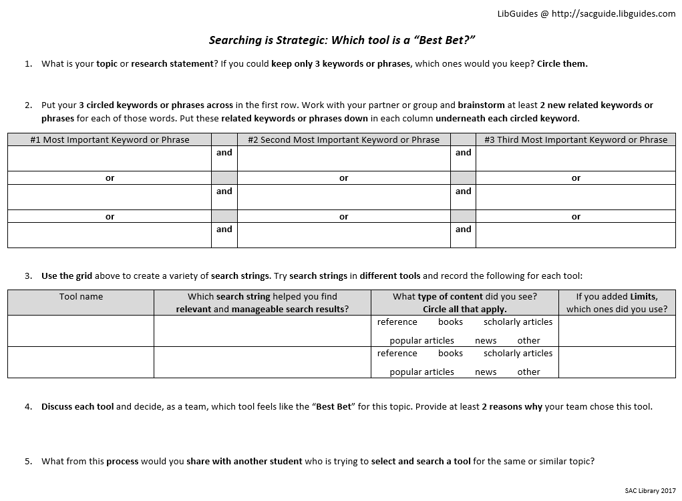
APPENDIX A
(CONTINUED)

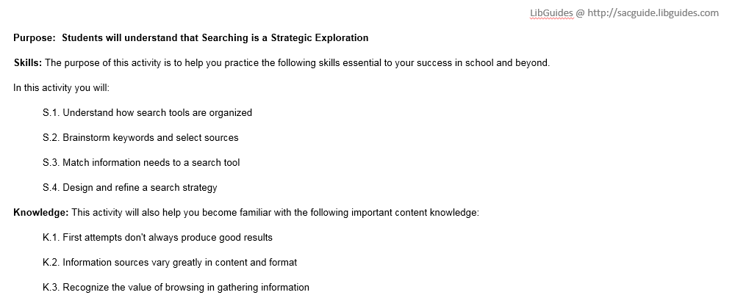
Appendix B
Wrap Up responses from students answering the question: “Which strategies would you share with another student who is researching the same topic?”

Responses from students NOT using SSW | Responses from students using SSW
Go to the LibGuides or the library to find all the necessary material for your topic. | I would tell them to limit their topic before researching, find a good place to search that accurately represents the topic, and try synonyms and different phrases while searching. The first article found might not be the best, but don’t give up?
I would advise to take notes and following along closely while the instructor is talking. I liked the General OneFile | I would recommend they use any of the collection tools available to them because it is important to browse and look around for a proper article. All of the tools are helpful because you can customize results and limit the search results by certain factors such as "peer reviewed," which is very helpful in making sure you are using a proper scholarly article or journal.
how to find books and where to check them out | Brainstorm to create a keyword grid to help yourself find more relevant sources. A certain word may not yield any results but that doesn't necessarily mean there aren't any sources for your research. Don't give up! You may just be searching for the wrong word. If it is taking too long to track down relevant sources, re-evaluate the topic you are planning on writing about.
Visiting the library will provide you with a lot of resources. | I would tell them to be very specific in what you want to search, and that you have to have keywords relating to the subject. the less articles you have the better, make sure that you limit the search also. you can do articles in the past 20 years and to make sure that they are scholarly.
Do more research. | Just keep trying. If the first search didn't pop up the results you need try every word you can possibly think categorizes in the same results. Use the limits if needed to be more specific.
Don’t be vague when looking up subjects. | Select the tool that seems to go along with their research topic, and utilizing the limits/source types to find exactly what you wanted.
Follow instructions and pay attention. | It's all about trial and error. Try the different databases using the same words and see what you find is more efficient.

Appendix C
Spring 2016 Wrap Up Form
1. I searched for this topic:

2a. I found new keywords which may help me develop or write about this topic:
Strongly Agree Agree Undecided Disagree Strongly Disagree

2b. Use 2 or 3 of these new keywords with AND to show how you might type in a search for this topic:

3. Which keyword search below would find the FEWEST number of search results?
a. internet
b. internet and students
c. internet and students and addiction
d. internet and student* and addict*
e. not sure!

4. I found items relevant to my topic:
Strongly Agree Agree Undecided Disagree Strongly Disagree

4b. One of the relevant items I found was called: (ie, a book title, article title or web site title)

5. I now have a better understanding of where to look for academic sources on a topic
Strongly Agree Agree Undecided Disagree Strongly Disagree

6. The concepts, skills, and resources I learned about today will help me complete my research
Strongly Agree Agree Undecided Disagree Strongly Disagree

7. Anything else you'd like to share with your librarian or instructor? Maybe one thing you learned that was new to you or something you still have questions about?

Appendix D
Spring 2017 Wrap Up Form
1. I'm researching the topic of addiction, but I'm not sure where to start. What should I probably do first?
a. find scholarly articles
b. narrow the topic with background info
c. ask your best friend for ideas
d. check out 10 books on the topic

2. I'm looking for sources on how college students are addicted to apps like Facebook and Instagram. I typed in the phrase "internet addicts" and found over 10,000 hits! Which search below would help me narrow my search to find the most relevant hits?
a. facebook
b. college students and addiction and social media
c. internet addiction in college
d. students and addicts

3. If I wanted to expand my search to find alternate endings of the keyword "addiction," which strategy would work best?
a. addictions*
b. add*
c. addicts*
d. addict*

4. What topic did you search for today?

5. Share 2 NEW keywords you found which may help you narrow/develop this topic:

6. I created a flexible search strategy for my topic.
Strongly Agree Agree Unsure Disagree Strongly Disagree

7. I found relevant academic sources for my topic.
Strongly Agree Agree Unsure Disagree Strongly Disagree

8. This class will help me complete my research.
Strongly Agree Agree Unsure Disagree Strongly Disagree

9. What was the most useful thing you learned in class today?

10. Do you have any questions or comments for me about today's class?

o Please send me more info about one-on-one:
o Research appointments (Book a Librarian)
o Writing Center tutoring

Appendix E
Spring 2018 Wrap Up Form

1. Think about the activities we did in today's class.
Which strategies would you share with another student who is researching the same topic?

2. Think about some of the next steps you need to take in order to complete your assignment.

Which of those next steps do you feel more confident tackling?

Which of those next steps still make you a little nervous?

3. What topic did you search for today?

4. How many library instruction sessions have you had here at SAC?

5. I created a flexible search strategy for my topic.

Strongly Agree Agree Unsure Disagree Strongly Disagree

6. I found relevant academic sources for my topic.
Strongly Agree Agree Unsure Disagree Strongly Disagree

7. This class will help me complete my research.
Strongly Agree Agree Unsure Disagree Strongly Disagree

o Please send me more info about one-on-one:
o Research appointments (Book a Librarian)
o Writing Center tutoring

